Traffic Violation ERD

John Wensink

MIS407-Database Concepts

Colorado State University-Global Campus

Professor-Nathan Braun

August 3, 2018

Traffic Violation ERD

This week’s CT assignment was to construct an entity-relationship diagram that models a traffic citation database. My career as an auto-claims adjuster requires that I analyze police reports of all different types from many different law enforcement agencies. Because of my experience, I noticed a few areas where the assignment has generalized the police report and I added a few attributes to make the model more realistic. The owner of the vehicle is not necessarily the driver, and a driver’s violation ought not to penalize the owner if they are not the same person. To this end, I have added the “owner_isdriver” boolean attribute to the vehicle entity type. If the “owner_isdriver” value is YES, the attributes for the owner are allowed to be NULL. Another area I felt the assignment could be improved is that a VIN would never be left blank on a police report, and would make the most sense to use as the vehicle entity type’s primary key, as a license plate number is a weak entity dependant on the plate’s state of issue. Additionally, signatures would not make sense to use as attributes, as they are likely images and therefore do not fit the relational model. Perhaps if we were using NoSQL it could work, but my education is not there yet. A few other relevant attributes were added such as owner info, officer badge number as a primary key, and fine amount. Although not included in the assignment, these attributes would add value to the database without much additional effort. I particularly enjoyed this assignment, and did my best to make it as realistic and (dare I say) useful as possible.

**ER Diagram**

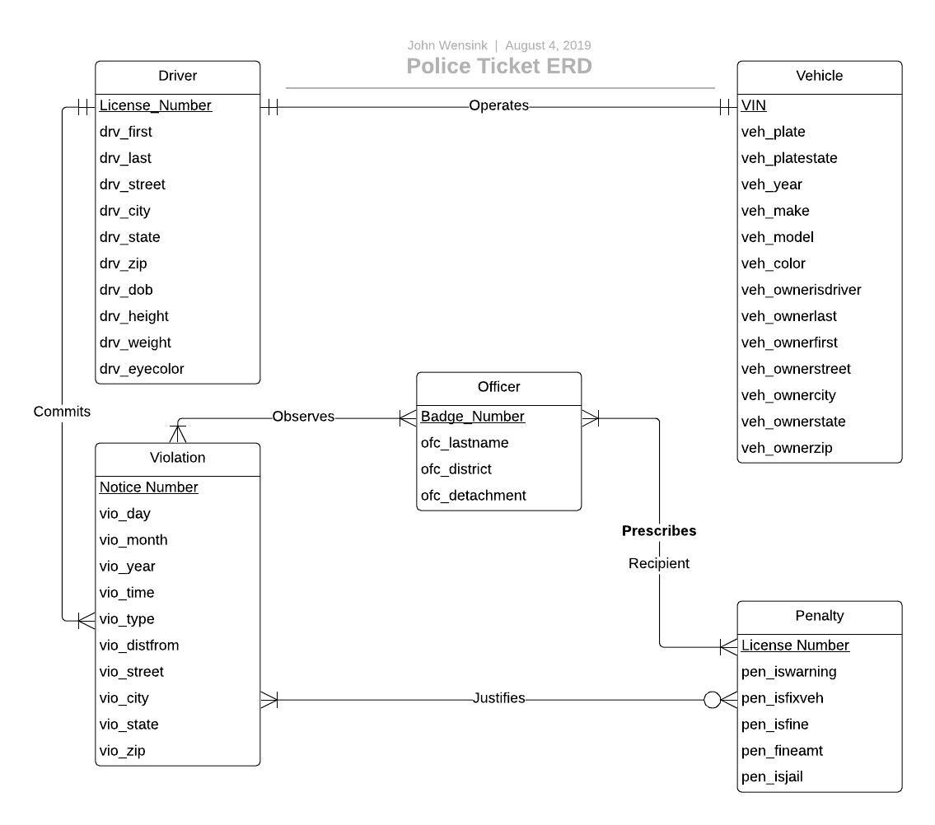

**Explanation of Relationships**

When we think about a traffic stop, it would be unusual for more than one driver to “operate” more than one vehicle. We will ignore driverless cars that may soon be available but aren’t quite ready yet. Therefore the cardinalities in the driver/vehicle relationship are both functional, that is to say, 1:1.

Let’s say the driver is speeding drunk down the road. This signifies a 1:M relationship between driver and violation, as the vehicle is operated by exactly one driver, who “commits” at least one violation but possibly more.

On patrol, Officer Friendly is manning the radar gun and Sergeant Slaughter is driving. Although it is possible for a single officer to observe a violation, it is more common for policemen to work with at least one partner, and they could both be called to testify in court. Officer Friendly clocks the driver going 100mph in a school zone. Sergeant Slaughter turns on his emergency lights and begins pursuit of the driver, who flees. Here, there are two violations at the minimum, but the speeding alone was sufficient cause to stop the vehicle. The policemen “observe” multiple violations and therefore the cardinalities of the officer/violation relationship are minimum one officer/violation and maximum many officers/violations.

The driver is forced off the road using the PIT maneuver, destroying the vehicle’s brake/running lights. When the policemen run the VIN the vehicle flags as stolen, and the registered owner is promptly notified of its recovery. This is a serious offense. The officers agree that the driver needs to be sent to jail. The owner is informed the vehicle is now in violation as it is not legal to drive on public roads. He is given written notice that his vehicle must be repaired before it can be driven. Here, one or more officers “prescribe” one or more penalties. This is a M:N relationship, and the relationship itself has the attribute of specifying who receives the penalty. (Mannino, 2019 p. 149)

The driver is taken to jail, and the vehicle owner has his car towed to the body shop. While the driver is getting booked into jail, a data scientist is able to “infer” from previous citations that this is not the driver’s first DUI. The driver’s action’s “justify” the penalties he faces which include jail time and a fine. Since this is not his first DUI he will likely lose his license as well, but that will be up to the court who has their own databse. The owner’s vehicle is legally inoperable and this “justify”(ies) the order to repair his vehicle. Had it been safe to operate there would be no penalty which makes the violation/penalty relationship optional with one or more violations justifying zero or more penalties.

**Physical database model.** We are in the process of moving into a new apartment here in Colorado Springs and staying out in the country for a few days at an Air B&B. There isn’t a whole lot to do around here so I thought I would make the physical database tables and try my hand at some CREATE TABLE statements to accompany the ERD for fun.

**Driver Table**

|  |  |  |  |
| --- | --- | --- | --- |
| **Attribute** | **Input** | **NotNull?** | **Key** |
| License_Number | Varchar (25) | Y | Primary |
| drv_firstname | Varchar (25) | Y | N/A |
| drv_lastname | Varchar (25) | Y | N/A |
| drv_street | Varchar (25) | N | N/A |
| drv_city | Varchar (25) | N | N/A |
| drv_state | Varchar (2) | N | N/A |
| drv_zip | Integer | N | N/A |
| drv_dob | Date | Y | N/A |
| drv_height (inches) | Integer | Y | N/A |
| drv_weight (lbs) | Integer | Y | N/A |
| drv_eyecolor | Varchar (25) | Y | N/A |

**Vehicle**

|  |  |  |  |
| --- | --- | --- | --- |
| **Attribute** | **Input** | **NotNull?** | **Key** |
| VIN | Varchar (25) | Y | Primary |
| veh_plate | Varchar (25) | Y | N/A |
| veh_platestate | Varchar (2) | Y | N/A |
| veh_year | Integer | Y | N/A |
| veh_make | Varchar (25) | Y | N/A |
| veh_model | Varchar (25) | Y | N/A |
| veh_ownerisdriver | Boolean | Y | N/A |
| veh_ownerlast | Varchar (25) | N | N/A |
| veh_ownerfirst | Varchar (25) | N | N/A |
| veh_ownerstreet | Varchar (25) | N | N/A |
| veh_ownercity | Varchar (25) | N | N/A |
| veh_ownerstate | Varchar (2) | N | N/A |
| veh_ownerzip | Integer | N | N/A |

**Officer**

|  |  |  |  |
| --- | --- | --- | --- |
| **Attribute** | **Input** | **NotNull?** | **Key** |
| Badge_Number | Varchar (25) | Y | Primary |
| ofc_lastname | Varchar (25) | Y | N/A |
| ofc_district | Varchar (25) | Y | N/A |
| ofc_detachment | Varchar (25) | N | N/A |

**Violation**

|  |  |  |  |
| --- | --- | --- | --- |
| **Attribute** | **Input** | **NotNull?** | **Key** |
| Notice_Number | Varchar (25) | Y | Primary |
| vio_day | Varchar (2) | Y | N/A |
| vio_month | Varchar (2) | Y | N/A |
| vio_year | Varchar (4) | Y | N/A |
| vio_time | Time | Y | N/A |
| vio_type | Varchar (25) | Y | N/A |
| vio_distfrom | Varchar (25) | Y | N/A |
| vio_street | Varchar (25) | Y | N/A |
| vio_city | Varchar (25) | Y | N/A |
| vio_state | Varchar (25) | Y | N/A |
| vio_zip | Varchar (25) | Y | N/A |

**Penalty**

|  |  |  |  |
| --- | --- | --- | --- |
| **Attribute** | **Input** | **NotNull?** | **Key** |
| License_Number | Varchar (25) | Y | Primary |
| pen_iswarning | Boolean | N | N/A |
| pen_isfixveh | Boolean | N | N/A |
| pen_isfine | Boolean | N | N/A |
| pen_fine_amt | Decimal (10,2) | N | N/A |
| pen_isjail | Boolean | N | N/A |

**SQL:**

CREATE TABLE Driver (

License_Number serial primary key VARCHAR(25),

drv_firstname VARCHAR(25) CONSTRAINT drv_firstname NOT NULL,

drv_lastname VARCHAR(25) CONSTRAINT drv_firstname NOT NULL,

drv_street VARCHAR(25),

drv_city VARCHAR(25),

drv_zip INTEGER,

drv_dob DATE CONSTRAINT drv_dob NOT NULL,

drv_height INTEGER CONSTRAINT drv_height NOT NULL,

drv_weight INTEGER CONSTRAINT drv_weight NOT NULL

drv_eyecolor VARCHAR(25)

);

CREATE TABLE Vehicle (

VIN serial primary key VARCHAR(25),

veh_plate VARCHAR(25) CONSTRAINT veh_plate NOT NULL,

veh_platestate VARCHAR(2) CONSTRAINT veh_platestate NOT NULL,

veh_year INTEGER CONSTRAINT veh_year NOT NULL,

veh_make VARCHAR(25) CONSTRAINT veh_make NOT NULL,

veh_model VARCHAR(25) CONSTRAINT veh_model NOT NULL,

veh_color VARCHAR(25) CONSTRAINT veh_color NOT NULL,

veh_ownerisdriver BOOLEAN CONSTRAINT veh_ownerisdriver NOT NULL,

veh_ownerfirst VARCHAR(25),

veh_ownerlast VARCHAR(25),

veh_owner VARCHAR(25),

veh_ownerlast VARCHAR(25),

veh_ownerfirst VARCHAR(25),

veh_ownerstreet VARCHAR(25),

veh_ownercity VARCHAR(25),

veh_ownerstate VARCHAR(2),

veh_ownerzip VARCHAR(5)

);

CREATE TABLE Officer (

Badge_Number serial primary key VARCHAR(25),

ofc_lastname VARCHAR(25) CONSTRAINT ofc_lastname NOT NULL,

ofc_district VARCHAR(25) CONSTRAINT ofc_district NOT NULL,

ofc_detachment VARCHAR(25) CONSTRAINT ofc_detachment NOT NULL

);

CREATE TABLE Violation (

Notice_Number serial primary key VARCHAR(25),

vio_day VARCHAR(2) CONSTRAINT veh_day NOT NULL,

vio_month VARCHAR(2) CONSTRAINT vio_month NOT NULL,

vio_year VARCHAR(4) CONSTRAINT vio_year NOT NULL,

veh_time TIME CONSTRAINT veh_time NOT NULL,

vio_type VARCHAR(25) CONSTRAINT vio_type NOT NULL,

vio_distfrom VARCHAR(25) CONSTRAINT vio_distfrom NOT NULL,

vio_street VARCHAR(25) CONSTRAINT vio_street NOT NULL,

vio_city VARCHAR(25) CONSTRAINT vio_city NOT NULL,

vio_state VARCHAR(2) CONSTRAINT vio_state NOT NULL,

vio_zip VARCHAR(5) CONSTRAINT vio_zip NOT NULL

);

CREATE TABLE Penalty (

License_Number serial primary key VARCHAR(25),

pen_iswarning BOOLEAN,,

pen_isfixveh BOOLEAN,

pen_isfine BOOLEAN,

pen_fineamt DECIMAL(10,2),

pen_isjail BOOLEAN,

)

References:

Mannino, M. (2019). Database design, application development, and administration (7th ed.). Retrieved August 3, 2019, from

<https://platform.virdocs.com/r/s/0/doc/592088/sp/46211890/mi/190879798?cfi=%2F4%2F8>